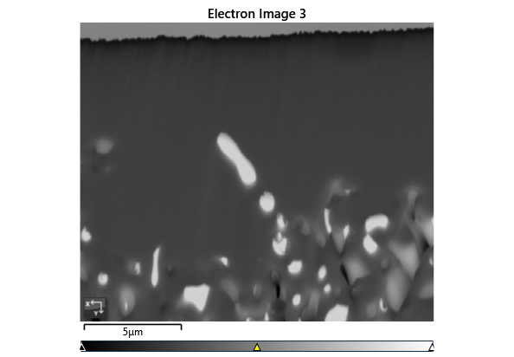

Settings

|  |  |
| --- | --- |
| Accelerating Voltage | 20.00 kV |
| Specimen Tilt (degrees) | 70.00 ° |
| Hit Rate | 83.60 % |
| Reanalysis Hit Rate | 82.38 % |
| Speed of Acquisition | 885.19 Hz |

Phases for Acquisition

|  |  |  |  |  |  |  |  |  |
| --- | --- | --- | --- | --- | --- | --- | --- | --- |
| Phase | a | b | c | Alpha | Beta | Gamma | Space Group | Database |
| Iron bcc (old) | 2.87 Å | 2.87 Å | 2.87 Å | 90.00 ° | 90.00 ° | 90.00 ° | 229 | HKL |
| Iron fcc | 3.66 Å | 3.66 Å | 3.66 Å | 90.00 ° | 90.00 ° | 90.00 ° | 225 | HKL |
| Nickel | 3.52 Å | 3.52 Å | 3.52 Å | 90.00 ° | 90.00 ° | 90.00 ° | 225 | OINA Phases |
| Pyrite | 5.42 Å | 5.42 Å | 5.42 Å | 90.00 ° | 90.00 ° | 90.00 ° | 205 | OINA Phases |

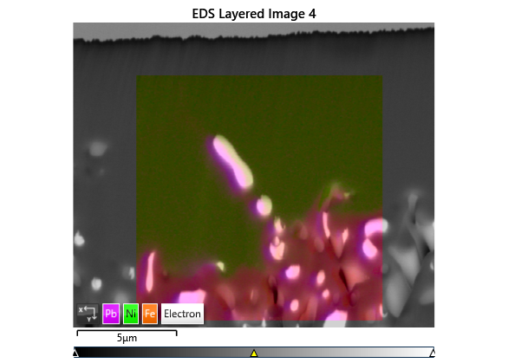

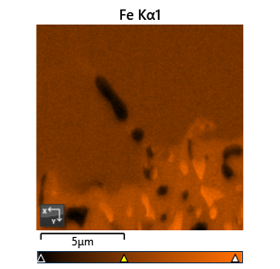

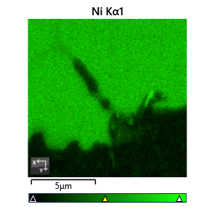

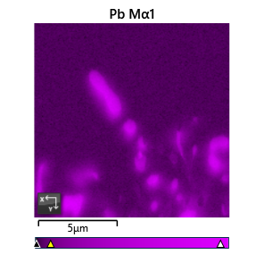

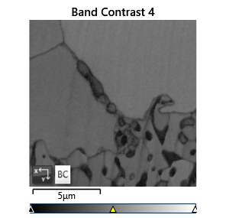

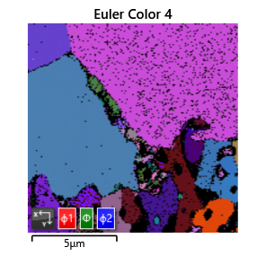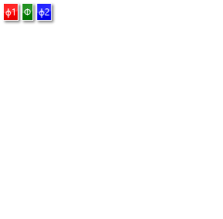

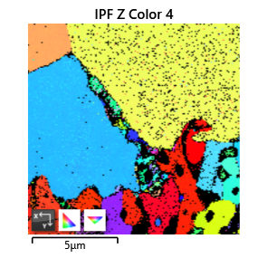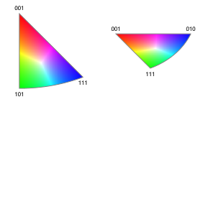

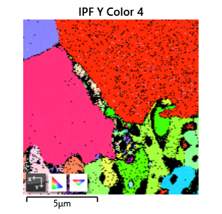

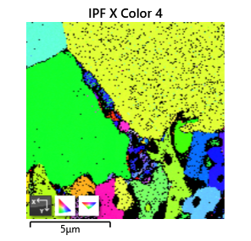

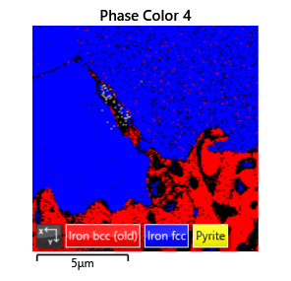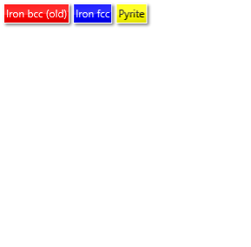

Phase Fraction

|  |  |  |  |  |  |  |  |  |  |  |
| --- | --- | --- | --- | --- | --- | --- | --- | --- | --- | --- |
| Phase Name | Phase Fraction (%) | Phase Count | Mean Band Contrast | Standard Deviation Band Contrast | Min Band Contrast | Max Band Contrast | Mean MAD | Standard Deviation MAD | Min MAD | Max MAD |
| Iron bcc (old) | 21.66 | 6445 | 91.70 | 12.37 | 24.00 | 122.00 | 0.84 | 0.28 | 0.20 | 1.99 |
| Iron fcc | 61.78 | 18383 | 104.57 | 11.63 | 25.00 | 126.00 | 0.76 | 0.22 | 0.12 | 1.99 |
| Nickel | 0.00 | 0 | 0.00 | 0.00 | 0.00 | 0.00 | 0.00 | 0.00 | 0.00 | 0.00 |
| Pyrite | 0.16 | 49 | 60.08 | 16.82 | 33.00 | 108.00 | 0.90 | 0.22 | 0.51 | 1.74 |
| Zero Solutions | 16.40 | 4879 | 65.97 | 30.38 | 0.00 | 123.00 |  |  |  |  |
|  |  |  |  |  |  |  |  |  |  |  |
|  |  |  |  |  |  |  |  |  |  |  |
| Phase Name | Reanalysis Fraction (%) | Reanalysis Count | Mean Band Contrast | Standard Deviation Band Contrast | Min Band Contrast | Max Band Contrast | Mean MAD | Standard Deviation MAD | Min MAD | Max MAD |
| Iron bcc (old) | 3.20 | 47 | 66.94 | 20.26 | 27.00 | 115.00 | 1.01 | 0.29 | 0.48 | 1.56 |
| Iron fcc | 75.85 | 1115 | 100.92 | 16.54 | 32.00 | 120.00 | 0.72 | 0.21 | 0.21 | 1.84 |
| Nickel | 0.00 | 0 | 0.00 | 0.00 | 0.00 | 0.00 | 0.00 | 0.00 | 0.00 | 0.00 |
| Pyrite | 3.33 | 49 | 60.08 | 16.82 | 33.00 | 108.00 | 0.90 | 0.22 | 0.51 | 1.74 |
| Zero Solutions | 17.62 | 259 | 52.68 | 24.79 | 0.00 | 116.00 |  |  |  |  |